|  |  |  |  |  |
| --- | --- | --- | --- | --- |
|  | French Horn Note | | Tuner Note | |
|  | A | | D | |
|  | A#/Bb | | D#/Eb | |
|  | B | | E | |
|  | C | | F | |
|  | C#/Db | | F#/Gb | |
|  | D | | G | |
|  | D#/Eb | | G#/Ab | |
|  | E | | A | |
|  | F | | A#/Bb | |
|  | F#/Gb | | B | |
|  | G | | C | |
|  | G#/Ab | | C#/Db | |
|  |  | |  | |
|  |  | |  | |
|  |  |  | |  | |  |  |  |

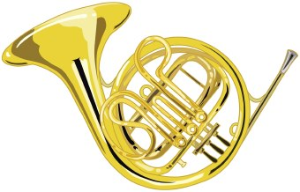

Horn to Tuner Note Converter